RECEPTIVE FIELD

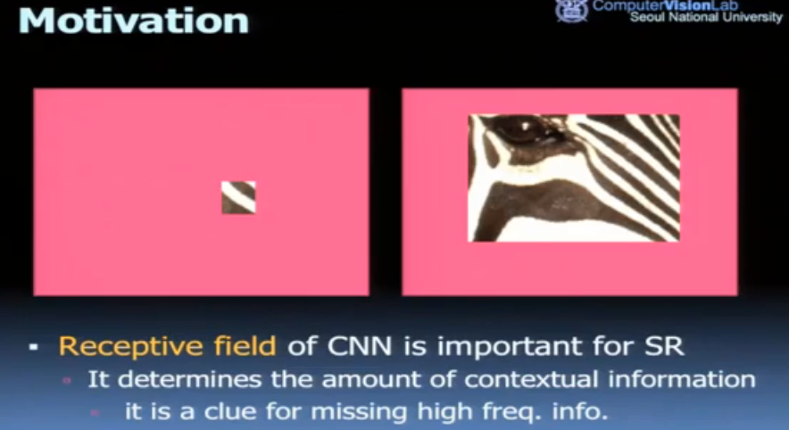

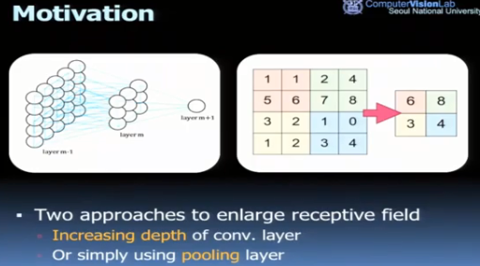

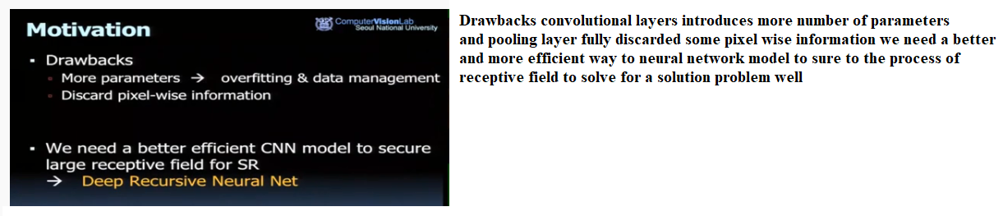

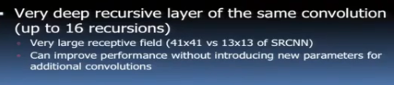

For image super-resolution (SR), receptive field of a convolutional network determines the amount of contextual information that can be exploited to infer missing highfrequency components. For example, if there exists a pattern with smoothed edges contained in a receptive field, it is plausible that the pattern is recognized and edges are appropriately sharpened.

Deep convolutional networks (DCN) succeeding in various computer vision tasks often use very large receptive fields (224x224 common in ImageNet classification[1,2]. Among many approaches to widen the receptive field, increasing network depth is one possible way: a convolutional (conv.) layer with filter size larger than a 1×1 or a pooling (pool.) layer that reduces the dimension of intermediate representation can be used. Both approaches have drawbacks: a conv. layer introduces more parameters and a pool. layer typically discards some pixel-wise information  
For image restoration problems such as super-resolution and denoising, image details are very important. Therefore, most deep-learning approaches for such problems do not use pooling. Increasing depth by adding a new weight layer basically introduces more parameters. Two problems can arise. First, overfitting is highly likely. More data are now required. Second, the model becomes too huge to be stored and retrieved.

[1] A. Krizhevsky, I. Sutskever, and G. E. Hinton. Imagenet classification with deep convolutional neural networks. In NIPS, 2012

[2] K. Simonyan and A. Zisserman. Very deep convolutional networks for large-scale image recognition. In ICLR, 2015